A Stallion is a male horse
A Mare is a female horse
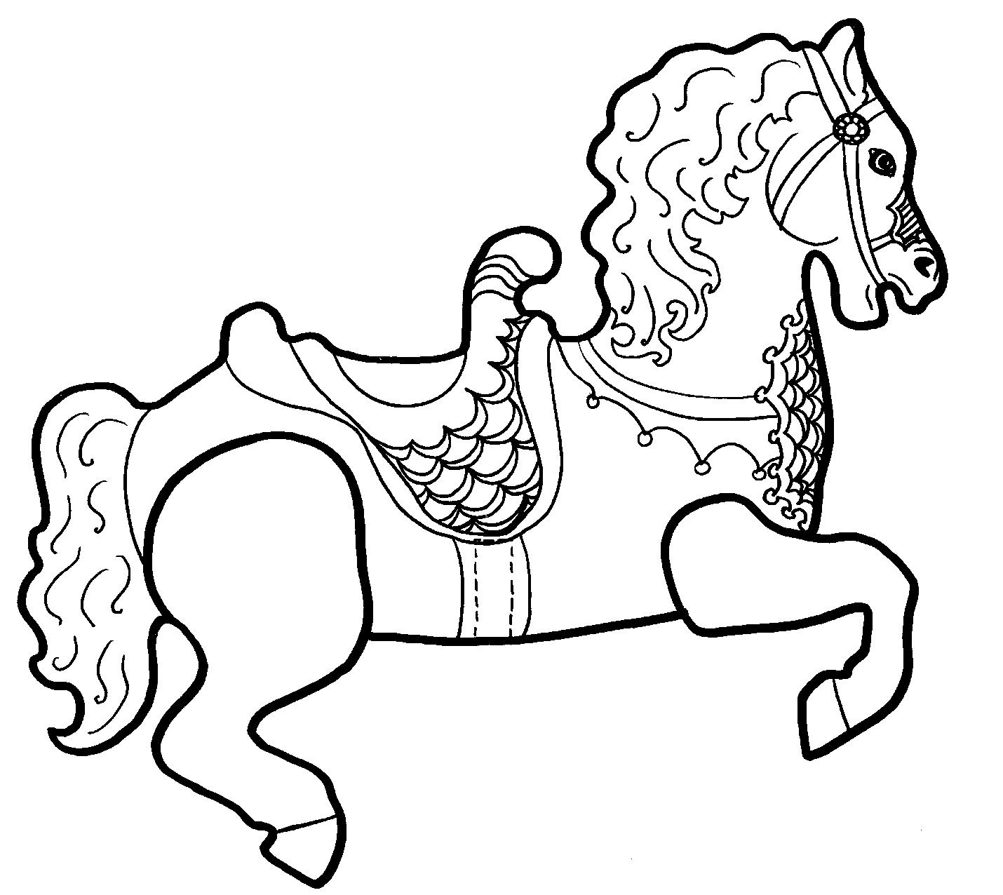

Every Farm needs a horse.
The Baxter Barn has three and they are great pets.
They are large and are solid-hoofed.
They eat grass or hay.

